B2: Reference material

The seven principles of EAFM

PURPOSE
To provide a background for the seven principles of EAFM.
HOW TO USE THIS DOCUMENT
The principles are core to many of the other documents, videos and activities and these descriptions can be used in many settings.
THE PRINCIPLES
EAFM is based on seven principles. None of these are new; they are all covered in the FAO Code of Conduct for Responsible Fisheries and common across many approaches, including Integrated Coastal Management (ICM) and coastal and marine spatial planning (CMSP).

Under an ecosystem approach all these principles need to be strengthened.

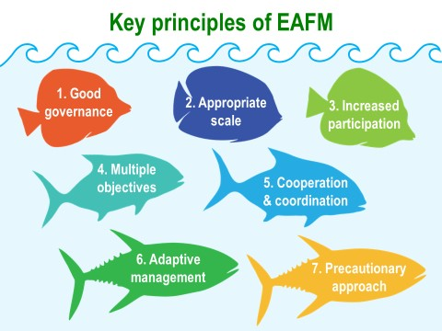

- Good governance: Process for developing rules and regulations for sustainable management and ensuring their compliance through a participatory process that improves acceptance, transparency and accountability;
- Appropriate scale: Suitable levels and processes at which management is applied, taking into account the nature of the fishery and the people involved, as well as the issues being addressed. This can cover political, geographic, socioeconomic, and temporal scales;
- Increased participation: The need for stakeholders to become involved and work effectively together in planning and implementation of EAFM;
- Multiple objectives: Addressing multiple objectives takes account of the various objectives of different stakeholders and considers trade-offs. It also strives to balance the multiple, often conflicting, objectives relating to human and ecological well-being;
- Cooperation and coordination: Voluntary but conscious and organized efforts of various stakeholder groups to work together to achieve EAFM objectives. Horizontal cooperation and coordination refer to efforts across sectors and agencies while vertical cooperation and coordination are across levels of government;
- Adaptive management: Iterative and systematic process for continually improving management by learning from the outcomes of the previous management objectives and actions; and
- Precautionary approach: Lack of data and information should not be used as an excuse for not taking action and where there is uncertainty, management actions should be less risky.

